Thanksgiving Pre Order Items
- Cider and Herb Turkey –
Medium (10-14 lb) or large (>14 lb) fresh turkey brined for 3 days in apple cider, herbs, aromatics, and brown sugar. Turkey comes with a cooking bag, precise cooking time, and simple instructions. This Turkey is always juicy and perfectly cooked when the instructions are followed. No mess, no stress!
Medium $87 Large $107
*1/2 pan serves 5-9 full pan serves 10-15
- Herbed Dressing/Stuffing –
Made with house baked sourdough bread, choice of
traditional Thanksgiving dressing or, sausage/apple/sage
Traditional ½ pan $35 Sausage ½ pan $40
Full pan $65 Full pan $75
- Turkey Pan Gravy –
Rich and flavorful gravy made with
turkey au jus seasoned with herbs
1 quart $14

- Au Gratin Potatoes –

Thinly grated potatoes baked in luscious, aged
cheddar sauce with a hint of roasted garlic
½ pan $40
Full pan $75
- Green Beans with Caramelized Onion and Bacon Jam –
French green beans tossed with sweet,
caramelized onion and smoky bacon jam.
½ pan $30
Full pan $55
- Green Bean Terrine –

Similar to a traditional green bean casserole. Creamy mushroom mornay
sauce and French green beans topped with crispy fried onions
½ pan $35
Full pan $65
- Balsamic Roasted Root Vegetables –
Tri-colored carrots, squash varieties, and sweet potatoes
roasted with aged balsamic vinegar
½ pan $35
Full pan $65

- Brown Butter Mashed Potatoes –

Decadent mashed potatoes made with butter that has been browned
to bring out its’ best qualities, blended with cream and
seasoned to perfection
½ pan $30
Full pan $55
- Cauliflower and Leek Au Gratin –

Roasted cauliflower and caramelized leeks baked with
creamy aged Gruyère and Fontina cheese sauce
½ pan $40
Full pan $75
- Harvest Vegetable Salad –

Roasted Brussels sprouts and squash, crisp apples,
tossed in cider vinaigrette *optional add creamy goat cheese*
½ pan $35 Add goat cheese $5
Full pan $65
-Spiced Cranberry Sauce –
Fresh cranberries cooked with fall spices,
honey crisp apples, and orange zest
1 quart $18
- Chacuterie Board –
Assorted meats and cheeses, artfully presented for you and your guests on an Acacia wood serving tray
15x11” tray $95 serves 6-8
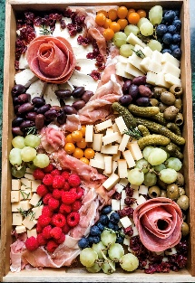
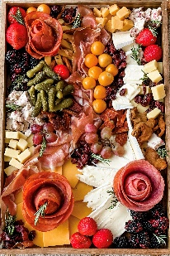
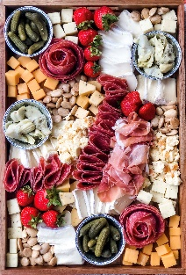

Thanksgiving Desserts

- Seminole Pumpkin Pie –
Local Florida Seminole pumpkin with traditional pumpkin
pie spices baked in a flaky hand made all butter pie crust
10 inch $40
Serves 8-10

- Apple Cranberry Pie -
Spiced apples and fresh cranberry filling with citrus
zest baked into a flaky hand made all butter pie crust
10 inch $48
Serves 8-10

- Seminole Pumpkin Cheesecake –

Local Florida Seminole pumpkin blended into a rich and creamy cheesecake filling
nestled in a handmade honey oat Graham cracker and brown butter crust
10 inch $68
Serves 12-15
- Old Fashioned Pecan Pie –
Toasted pecans baked in creamy dark brown sugar caramel
custard in a flaky hand made all butter pie crust
*optional add chopped Belgian chocolate*
10 inch $48
10 inch with Belgian chocolate $56
Serves 8-10

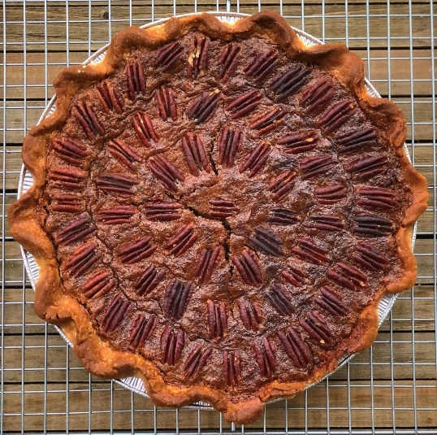
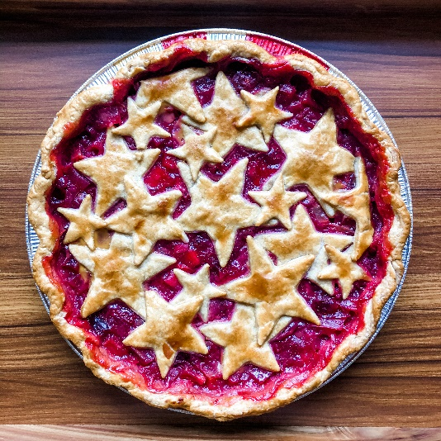

Thanksgiving Pre Order Form

Comments or special instructions:
If needed enter special instructions here

*Please email orders to ToastedSugarSweets@gmail.com
Name | phone number | Delivery address | Today’s Date
Name | Phone Number | Address | Click or tap to enter a date.

Quant | Item Name | Price
 | Click or tap here to enter text.
 | Click or tap here to enter text.
 | Click or tap here to enter text.
 | Click or tap here to enter text.
 | Click or tap here to enter text.
 | Click or tap here to enter text.
 | Click or tap here to enter text.
 | Click or tap here to enter text.
 | Click or tap here to enter text.
 | Click or tap here to enter text.
TOTAL DUE | Enter Total
Payment in full is due at time of order placement
Payment can be made via Zelle at ToastedSugarSweets@Gmail.com or scan QR code
For credit or debit card payments, please call us at (312)909-2882
All credit or debit card transactions are subject to a 3.6% processing fee

You will receive a confirmation email once payment is received. You will also receive your delivery date in the confirmation email. Delivery dates range from 11/21-11/22

*Orders must be placed by November 11th and are subject to availability due to limited delivery time slots

www.ToastedSugarBakery.com
Thank you for your business!

